Monitoring, control and process optimisation all in one valve
At the beginning of July 2025, KSB SE & Co. KGaA launched the new BOA-Systronic ePIC onto the market. The intelligent control valve is designed for automated operation in building services and industrial heating and cooling systems.

It independently performs key tasks such as shutting off, measuring and controlling the volume flow rate, supply and return temperature (temperature differential) and thermal output. These functions are integrated into the valve, eliminating the need for external measuring systems, control components and time-consuming programming work.

The integrated and patented ultrasonic volume flow measurement enables continuous energy monitoring of all relevant system and operating parameters, bringing transparency to modern heating and cooling networks. It also makes operational monitoring and maintenance planning as well as the optimisation of complex hydraulic systems considerably easier.

Thanks to the integrated and pre-parameterised control functions for volume flow rate, temperature and thermal output, optimum system operation and hydraulic balancing are ensured in all load scenarios.

Another advantage of the new valve is that it offers targeted hydraulic optimisation of individual consumer installations. Effective delta T management for heat exchangers enables users to improve energy efficiency and make operation more economical. Furthermore, a variety of limitation functions are available to adjust the valve to specific requirements or further optimise it during operation.

All functions can be operated both during commissioning and ongoing operation via the KSB FlowManager app, the KSB app for pumps and valves. The pre-installed control and optimisation functions can be activated intuitively via the app and make commissioning easy.

The KSB FlowManager app and the standardised interfaces (24 V AC/DC, analog and Modbus RTU) ensure simple integration into building management systems and full availability of all recorded data. This allows any deficient conditions or deviations in process values and energy consumption to be detected and prevented at an early stage, as required by the European Union's Energy Performance of Buildings Directive (EPBD) and the German Buildings Energy Act (GEG).

Thanks to the standard face-to-face length (EN 558/1) for the entire range of nominal diameters (DN 15–200), it is easy to replace existing valves during refurbishment work and simple to install the valve in new systems. BOA-Systronic ePIC is the intelligent all-in-one solution. It combines the features of a classic control valve with energy monitoring and smart control and optimisation functions for hydraulic balancing in a single valve.
In addition to simplifying planning, commissioning and ongoing system operation, it increases the energy efficiency of modern heating and cooling systems while maximising user-friendliness.

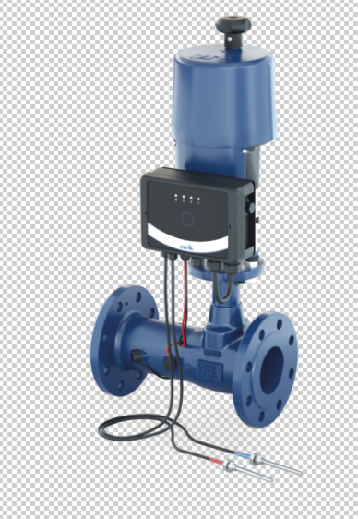

Photo: The new BOA-Systronic ePIC helps to simplify system operation and increase the energy efficiency of building services and industrial heating and cooling systems. (© KSB SE & Co. KGaA)

