Emergency kit for basement drainage
In times of increasingly frequent heavy rain events, that are becoming more and more challenging for private households and commercial operations alike, public flood control measures often reach their limits. It is all the more important that a larger number of households, companies and public facilities are ready to help themselves. This is where KSB’s Flood Fighter L comes into play, presented by the KSB Group at ISH 2025 in Frankfurt.
It is a powerful plug-and-play drainage solution of very high quality, developed and manufactured in Germany. This innovative emergency drainage kit offers an impressive capacity of 28,000 litres per hour, which corresponds to more than 150 bathtubs full of water. Unlike conventional emergency drainage kits from the DIY store, KSB’s Flood Fighter L is a professional solution that provides reliable help in the event of flooding.
At the heart of the system is a powerful pump from the AmaDrainer 507 series. The robust motor design makes for a long service life and can handle short periods of dry running. The pump has been designed for reliable continuous operation. With its 20-metre power cable, remote parts of buildings can be reached without any problem. Its 15-metre drainage hose is fitted with Storz C couplings at both ends to allow an extension with hoses of identical design. The scope of supply includes an adapter for connecting the hose to the pump.
The pump is safely stored and transported in the robust plastic crate. During pump operation, the crate also serves as a coarse filter and provides additional protection against the intake of foreign particles. The kit further contains safety gloves. They protect the user’s hands and provide a safe grip, even in wet and muddy environments. Optionally, a power generator is available for operating the emergency drainage kit if the public power is off.
Heavy rain events are characterised by high-intensity precipitation over a short duration and confined to a localised geographical area. Such events frequently occur in the summer months and are often linked with thunderstorms. They can form anywhere and often lead to dramatic flooding events, putting people’s lives as well as buildings and vehicles at risk. The intensity and frequency of heavy rain events has risen over the last few years. This is explained by climate change causing extreme weather conditions. Heavy rain can result in significant damage, especially in urban areas, where public sewers often do not have the capacity to drain such large volumes of water in a short time.
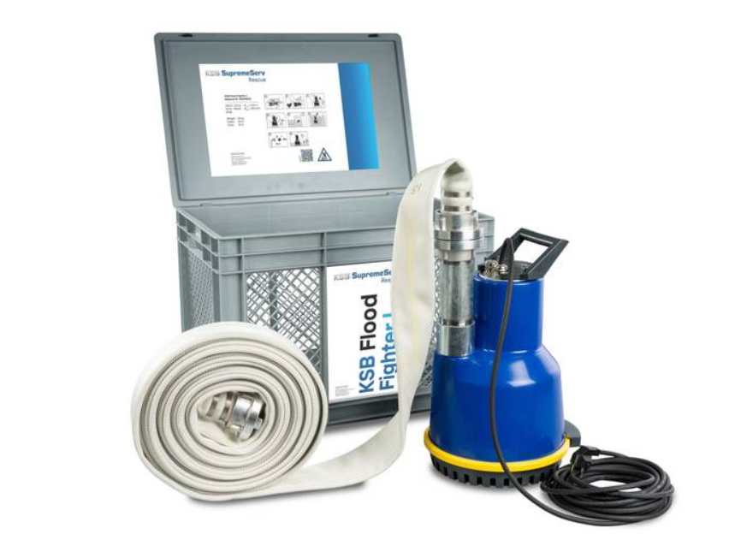
Photo: KSB’s Flood Fighter L is a plug-and-play drainage kit of very high quality, enabling households, companies and public facilities to help themselves in heavy rain events. ©KSB SE & Co. KGaA

