Multifunctional valves for integration in energy management systems

The German Buildings Energy Act (GEG 2024) in its version of 2024 stipulates that building management systems must use energy-efficient components to support economical and reliable operation. With its new BOATRONIC 100 MOD measuring computer, the KSB Group offers specialist consultants and operators a cost-effective and compact option to meet the new legal requirements.

The new measuring computers effectively turn the BOA-Control IMS balancing and shut-off valve into an energy monitoring system for modern HVAC systems. Users do not need any additional measuring systems to implement this monitoring solution. Flow direction, volume flow rate, supply and return temperature as well as thermal output and quantity of heat are measured directly at the valve. Key applications are monitoring and hydraulic balancing in hot-water heating systems, air-conditioning systems and cooling circuits as well as other applications where flow rate and/or temperature need to be measured.

The integrated ultrasonic flow measurement is based on the principle of transit time difference and enables fast and reliable measurement of the actual volume flow rate values without having to enter the valve position. Designed with innovative ultrasonic sensors that are not in contact with the fluid handled, the measurement system is leak-free and insensitive to deposits or contamination.

In addition, the new measuring computers provide two further temperature sensors for the supply and return lines, allowing the supply and return temperature to be recorded, as well as thermal output and quantity of heat. Additional diagnosis functions, such as the automatic display of the flow direction, increase operating reliability. Integration in building management systems is enabled by two analog interfaces as well as Modbus RTU. In this way, all process parameters will always be available in the higher-level management system, contributing substantially to system and process transparency. An intuitive app (KSB FlowManager) makes commissioning and measurement easy.

The standard face-to-face length of BOA-Control IMS to EN 558/1 offers users maximum flexibility. The valve's interchangeability makes it the ideal choice whenever monitoring solutions need to be implemented as part of the energy-efficient refurbishment of existing systems.

Another benefit of BOA-Control IMS is its broad application range, with nominal sizes ranging from DN 15 to DN 350 at a flow velocity of up to four metres per second. It is suitable for monitoring water in heat transfer systems as well as water/glycol mixtures in cooling systems. The measurement system integrated in the valve and the new measuring computers (BOATRONIC 100 MOD) do away with the need for costly measurement systems such as magnetic-inductive flow sensors.

For digital planning (BIM), optimised product data records are available in all common programs and databases. EKB, a variant with electrostatic plastic coating, is available for drinking water applications as well as for oil-free cooling circuits.

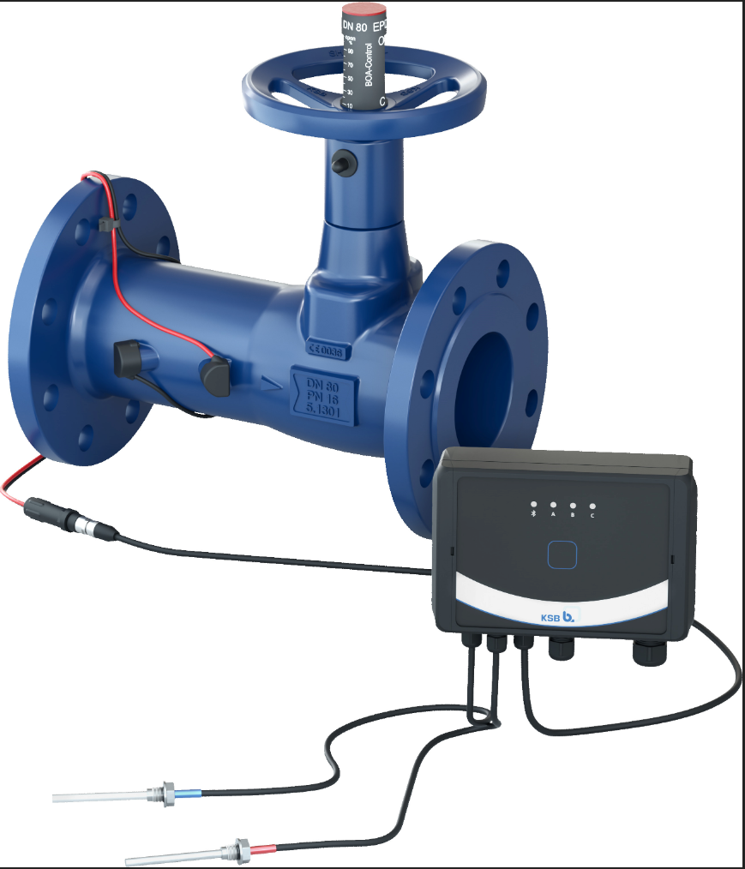
Photo: BOA-Control IMS and BOATRONIC MOD for permanent process monitoring and communication via analog and Modbus interface (©KSB SE & Co. KGaA)

